ONLINE WEBINARS AND TRAININGS
Each of these trainings can serve as ONE HOUR of professional development credit.
You MUST provide some proof of completion – an email verification of your completion, a certificate of completion from the organization, etc. For some trainings, these certificates are only provided hard-copy if paid for. If this is the case, and you’d prefer not to pay, you may pull up an electronic version of the training and take a screen shot or photo of your computer.

SOPHE LIVE WEBINARS for PROFESSIONAL DEVELOPMENT HOURS
The Society for Public Health Education organizes a wide variety of live webinars, each with a different topical focus, across the semester. Most webinars are about an hour in length and are free to access. Some may come with a minimal cost, and while you are not required to select any that require a payment, you are welcome to do so – if the topic or speaker sounds meaningful to you and you’re willing to front the cost.
If you following this link (https://www.sophe.org/calendar), you will be taken to their calendar page, which is updated throughout the year, providing information regarding upcoming webinars. Clicking on an individual webinar link will take you to the page for the particular webinar. For most, if you scroll down, you will find an information box like the one below:
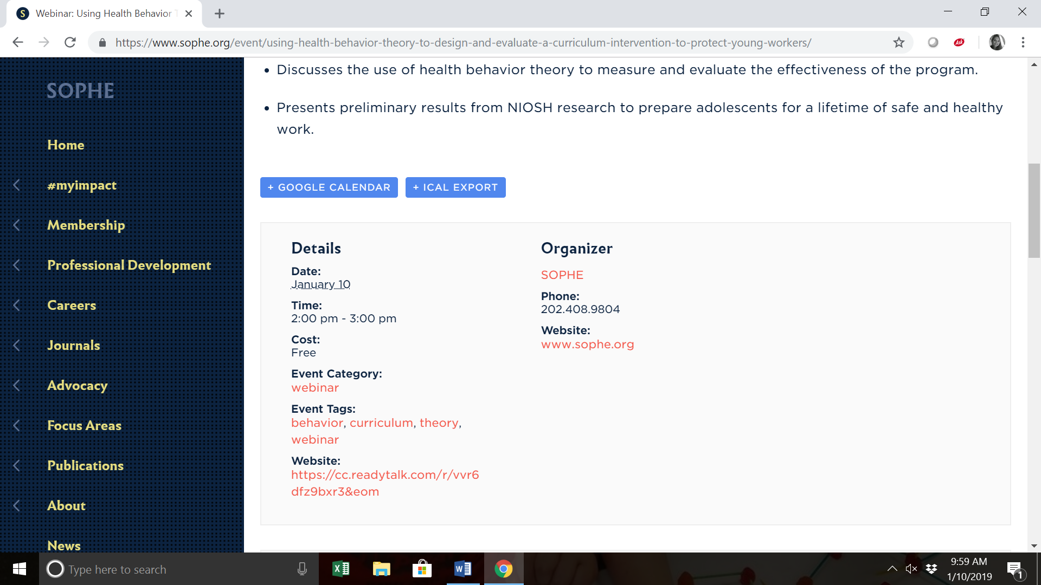
As you can see above, there is a website link. You’ll need to visit this link to officially register for the event. Some are limited in attendance, so you may want to do so early. You should receive information from the webinar organizer through email regarding how to access the content on the day the webinar takes place.
To receive your “signature” for your log, you’ll need to take a screenshot of the webinar on your computer during its airing. To do, for most operating systems, you’ll need to simultaneously hold down the “control” button with the “print screen” button on your keyboard. This will create a screen shot of what’s on your computer at that time. You can then open WORD or another processing system, and hit the “paste” function (or control + V) to paste the screenshot into a word document. You’ll turn this in for “proof” of attendance at the end of the semester. You may want to practice using the print screen on your computer before the webinar, to ensure that you are able to do so during your viewing.
CORE WEBINARS from SOPHE
If you’re unable to attend and view a live webinar, SOPHE also offers a wide variety of previous seminars, webinars, and conference presentations that you can access, to be used in the same light as a live recording. These are catalogues through a system called “CORE.” You can access CORE at the website link that follows: https://beacon360.content.online/xbcs/S1581/catalog/main.xhtml. The homepage looks something like this:
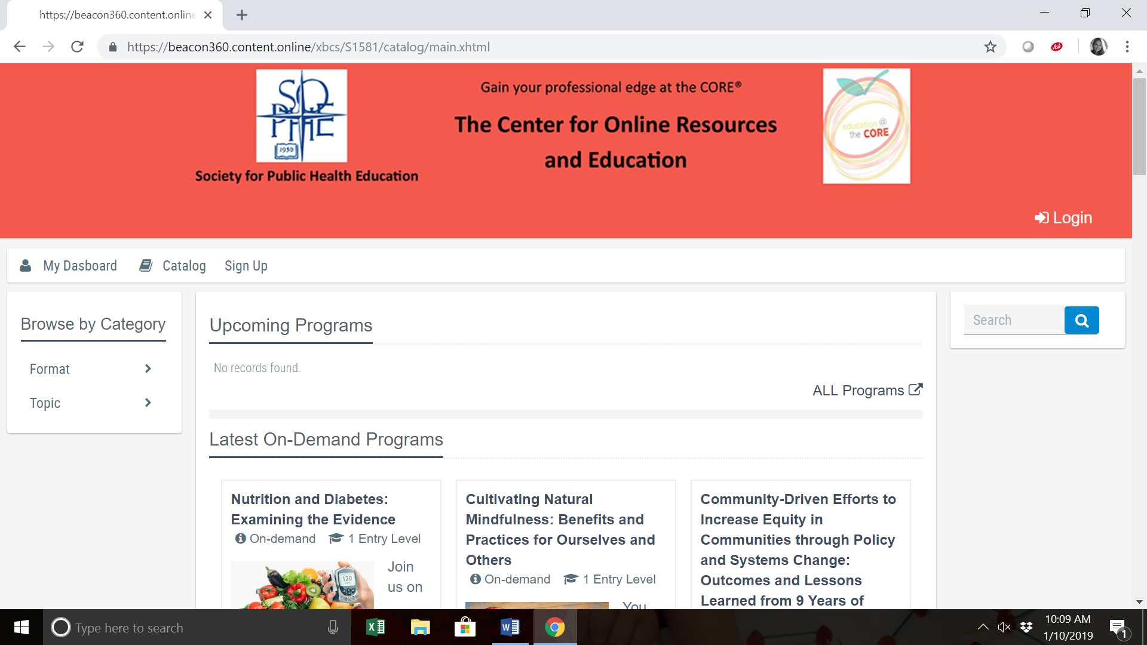

I would encourage that you browse by topic to find webinars that seem interviewing to you. However, do note that a number of older webinars are only available at a cost. Again, you are welcome to pay for these, but it is not a requirement.
To establish proof of viewing, use the same method as discussed above – screenshotting your computer during your viewing.
UNIVERSITY OF MICHIGAN PUBLIC HEALTH TRAINING CENTER
Similar to CORE above, the University of Michigan Public Health Training Center offers a wide variety of free online trainings on a variety of public health topics. You can access the catalogue of available options at: https://www.mitrainingcenter.org/. Selecting a specific training will take you to a page providing details on how to access that particular training. For many, you will need to sign up – and the course will be administered using a self-paced CANVAS course, including content to review, a quiz/evaluation, and a “certificate” you get after passing the quiz to verify your completion. This certificate must be printed and turned in at the end of the semester with your lab report. You DO NOT need to pay for CE credits – these are required of public health educators who are obtaining continuing education credits to keep their CHES certification active.
If you have any questions regarding these trainings, please don’t hesitate to let me know.

ONLINE TRAINING FROM MISCELLEANOUS SOURCES
https://www.globalhealthlearning.org/certificate-programs
https://lms.southcentralpartnership.org/course/index.php
https://nciph.sph.unc.edu/tws/index.php
https://www.nwcphp.org/training/training-search#b_start=0
http://www.sph.umn.edu/academics/ce/courses/

